**TITLE (TNR, 14, BOLD, CENTER, SINGLE SPACING, UPPERCASE)**

**Adam Hafiz1 (superscript)**

**Amzar2 (superscript)**

**Hannah3 (superscript)**

**(TNR, 12, Bold, Centre, Single Spacing, Capitalize Each Word)**

1Faculty Economic, Universiti Utara Malaysia (UUM), Malaysia, (E-mail: adam@uum.edu.my)

2Faculty Account, Universiti Utara Malaysia (UUM), Malaysia, (Email: amzar@uum.edu.my)

3Faculty Finance, Universiti Teknologi Mara (UiTM), Malaysia, (E-mail: hannah@uitm.edu.my)

(TNR, 10, Align Left, Capitalize Each Word)

__________________________________________________________________________________________

***Abstract:*** (*TNR, 12, italic, justify, single spacing) - The abstract should* ***not more than 300 words each****. The abstract should not only indicate the subject and scope of the paper, but also summarize the author’s conclusion. Structured abstract must be a brief, comprehensive summary of the contents of the article. It allows readers to survey the contents of an article quickly. An Abstract summarizes the major aspects of a paper. It should succinctly summarize the purpose of the paper, the methods used, the major results, and conclusions.*

**Keywords:** *(TNR, 12, Italic, Justify, Single Spacing, Capitalize Each Word) - Min 3 Keywords and Max 5 Keywords*

***___________________________________________________________________________***

**Introduction – Heading 1 (TNR, 12, Bold, Align Left, Capitalize Each Word)**

Tourism is one of the fastest growing development sectors in addition to other development strategic agendas such as energy, food, infrastructure ………….

(TNR, 12, single spacing, justify)

**Literature Review – Heading 1 (TNR, 12, Bold, Align Left, Capitalize Each Word)**

**Definition of Rural Tourism – Heading 2 (TNR, 12, Bold, Italic, Tab Inside, Capitalize Each Word)**

Sustainable tourism as defined by The World Tourism Organization (UNWTO) is tourism that takes full account of current and future economic, social and environmental impacts…

(TNR, 12, single spacing, justify)

**Rural Tourism – Heading 3 (TNR, 12, Bold, Italic, 2 Times - Tab Inside, Capitalize Each Word)**

The goal of sustainable tourism is to reduce poverty, respect socio-cultural authenticity, and be responsible for the use of environmental resources, and not only encourage but also….…

(TNR, 12, single spacing, justify).

**Table 1: Example (TNR, 12, Single Spacing, Bold, Centre, Capitalize Each Word)**

|  |  |  |
| --- | --- | --- |
| **Example** | **Example** | **Example** |
| Example | Example | Example |
| Example | Example | Example |

Source: (TNR,10, Single Spacing, Align Left, Capitalize Each Word)

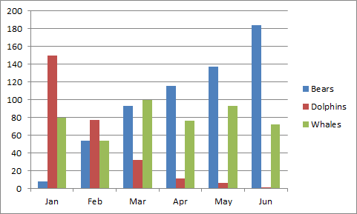

**Figure 1: Example (TNR, 12, Single Spacing, Bold, Centre, Capitalize Each Word)**

Source: (TNR,10, Single Spacing, Align Left, Capitalize Each Word)

**References (APA Sixth Edition, Single Spacing)**

**Criteria for Best Paper Award:**

* empirical paper

* minimum references are 15 (80% from published work-Journal)

* Referencing style is APA 6

* minimum 6 pages and maximum 15 pages (around 4000 words)

* follow format of full paper

* submit paper before 19 June 2020

* join as presenter in conference

**Notes:**

* Please remove any numbering on heading and subheading.

* Example for numbering figure are: Figure 1, Figure 2, Figure 3 ….so on.

* Example for numbering table are: Table 1, Table 2, Table 3 …….so on.

* Please refer above example for table and figure.

* Please remove the page number

* Margin Normal: Top (2.54cm), Bottom (2.54cm), Left (2.54cm), Right (2.54cm)

**PLEASE SUBMIT YOUR FULL PAPER IN MICROSOFT WORD FORMAT**