Volume: x Issues: x [xx, xx] pp.xx-xx]
Journal (xxxxxx)
eISSN: xxxxxx
Journal website: xxxxx

TITLE (TNR, 16, CENTER, UPPERCASE)

Author (TNR, 12, Center, Capitalize Each Word) ¹

¹Author details (TNR, 10, align left)

Accepted date: Published date:

To cite this document:
__________________________________________________________________________________________

Abstract :( TNR, 12, italic, single spacing).

Keywords: (TNR, 12, italic, single spacing, capitalized each word)
___________________________________________________________________________
Introduction (TNR, 12, bold, align left)

Tourism in rural areas plays an important role …… (TNR, 12, single spacing, justify)
One space between paragraph
Definition of tourism……(TNR, 12, single spacing, justify)

Literature Review (TNR, 12, bold, align left)

Definition and Concepts of Rural Tourism ((TNR, 12, bold, italic, align left)

In particular, Irshad (2010)’s review of Page and Getz (1997)……. (TNR, 12, single spacing, justify).
Table 1: Example (TNR, 10, single spacing, bold, centre)
Example | Example | Example
Example | Example | Example
Example | Example | Example

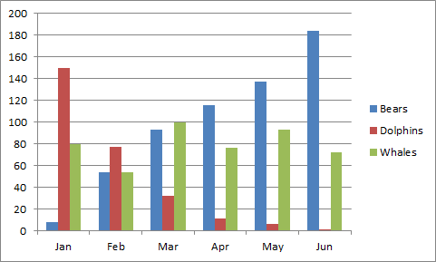
Figure 1: Example (TNR, 10, single spacing, bold, centre)

References (APA Sixth Edition) – TNR, 12, single spacing
Notes:
* minimum references are 15
* minimum 6pages and maximum 20pages
* TNR, 12, spacing 1.0
* For paper in Malay, please provide also title, abstract and keywords in English.
**The minimum are 15 references.

