TITLE (TNR, 16, CENTER, UPPERCASE)

Author (TNR, 12, Bold, Centre, Capitalize Each Word) ¹

¹Author details (TNR, 10,)

__________________________________________________________________________________________

Abstract :( TNR, 12, italic, single spacing).

Keywords: (TNR, 12, single spacing)
___________________________________________________________________________

Introduction (TNR, 12, bold, align left)

Tourism in rural areas plays an important role …… (TNR, 12, single spacing, justify)

Literature review (TNR, 12, bold, align left)

Definition and concepts of rural tourism ((TNR, 12, bold, italic, align left)

In particular, Irshad (2010)’s review of Page and Getz (1997)……. (TNR, 12, single spacing, justify).
Table 1: Example (TNR, 10, single spacing, bold, centre)
Example | Example | Example
Example | Example | Example
Example | Example | Example

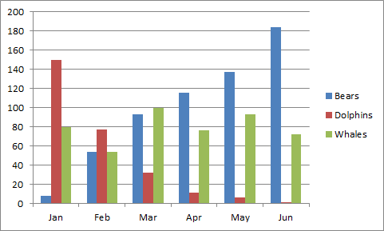
Figure 1: Example (TNR, 10, single spacing, bold, centre)

References (APA Sixth Edition)

