TITLE (TNR, 14, BOLD, CENTER, SINGLE SPACING, UPPERCASE)

Adam Hafiz^{1 (superscript)}
Amzar2 (^{superscript})
Hannah3 (^{superscript})
(TNR, 12, Bold, Centre, Single Spacing, Capitalize Each Word)

(^{superscript}) ¹Faculty Economic, Universiti Utara Malaysia (UUM), Malaysia, (E-mail: adam@uum.edu.my)
(^{superscript}) ²Faculty Account, Universiti Utara Malaysia (UUM), Malaysia, (Email: amzar@uum.edu.my)
(^{superscript}) ³Faculty Finance, Universiti Teknologi Mara (UiTM), Malaysia, (E-mail: hannah@uitm.edu.my)
(TNR, 10, Align Left, Capitalize Each Word)
__________________________________________________________________________________________

Abstract: (TNR, 12, italic, justify, single spacing) - The abstract should not more than 300 words each. The abstract should not only indicate the subject and scope of the paper, but also summarize the author’s conclusion. Structured abstract must be a brief, comprehensive summary of the contents of the article. It allows readers to survey the contents of an article quickly. An Abstract summarizes the major aspects of a paper. It should succinctly summarize the purpose of the paper, the methods used, the major results, and conclusions.

Keywords: (TNR, 12, Italic, Justify, Single Spacing, Capitalize Each Word) - Min 3 Keywords and Max 5 Keywords
___________________________________________________________________________

Introduction – Heading 1 (TNR, 12, Bold, Align Left, Capitalize Each Word)
Tourism is one of the fastest growing development sectors in addition to other development strategic agendas such as energy, food, infrastructure ………….
(TNR, 12, single spacing, justify)

Literature Review – Heading 1 (TNR, 12, Bold, Align Left, Capitalize Each Word)
Definition of Rural Tourism – Heading 2 (TNR, 12, Bold, Italic, Tab Inside, Capitalize Each Word)
Sustainable tourism as defined by The World Tourism Organization (UNWTO) is tourism that takes full account of current and future economic, social and environmental impacts…
(TNR, 12, single spacing, justify)

Rural Tourism – Heading 3 (TNR, 12, Bold, Italic, Tab Inside, Capitalize Each Word)
The goal of sustainable tourism is to reduce poverty, respect socio-cultural authenticity, and be responsible for the use of environmental resources, and not only encourage but also….…
(TNR, 12, single spacing, justify).

Table 1: Example (TNR, 12, Single Spacing, Bold, Centre, Capitalize Each Word)
Example | Example | Example
Example | Example | Example
Example | Example | Example
Source: (TNR,10, Single Spacing, Align Left, Capitalize Each Word)

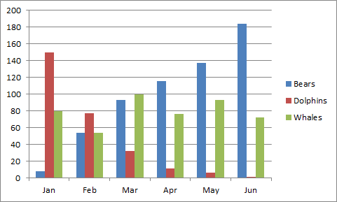
Figure 1: Example (TNR, 12, Single Spacing, Bold, Centre, Capitalize Each Word)
Source: (TNR,10, Single Spacing, Align Left, Capitalize Each Word)

References (APA Sixth Edition, Single Spacing)
Criteria for Best Paper Award:

* empirical paper
* minimum references are 15 (80% from published work-Journal)
* Referencing style is APA 6
* minimum 6 pages and maximum 12 pages (around 4000 words)
* follow format of full paper
* submit paper before 26 November 2018
* join as presenter in conference

Notes:

* Please remove any numbering on heading and subheading.
* Example for numbering figure are: Figure 1, Figure 2, Figure 3 ….so on.
* Example for numbering table are: Table 1, Table 2, Table 3 …….so on.
* Please refer above example for table and figure.
* Please remove the page number
* Margin Normal: Top (2.54cm), Bottom (2.54cm), Left (2.54cm), Right (2.54cm)

